Microservices Event Driven Using Apache Kafka and RabbitMQ

What is Apache Kafka and RabbitMQ ?
Apache Kafka is a distributed event streaming platform.
Instead of just passing messages from one service to another, Kafka stores a continuous log of events that many systems can read from.
Think of it as a high-speed data pipeline plus storage for events
Data is written as events to a topic.
Those events remain stored for a configurable time, and many consumers can read them independently.

Main components
- Producer → sends events
- Kafka Broker → stores events
- Topic → category/stream of events
- Partition → parallel processing
- Consumer → reads events

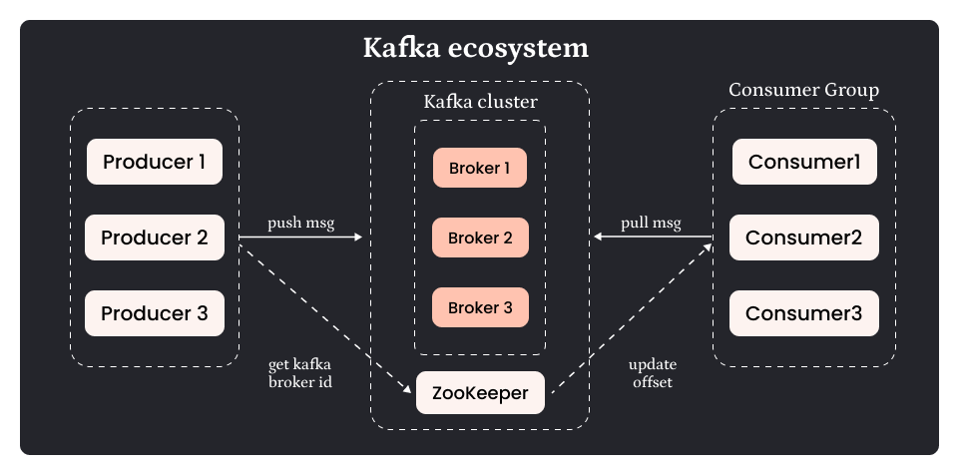

RabbitMQ is the message broker designed for reliable message delivery between services
It follows traditional queue based messaging system
Messages go to an exchange, which routes them to queues, and workers consume them.
Main components
- Producer
- Exchange
- Queue
- Consumer
RabbitMQ supports routing patterns:
- direct
- topic
- fanout
- headers
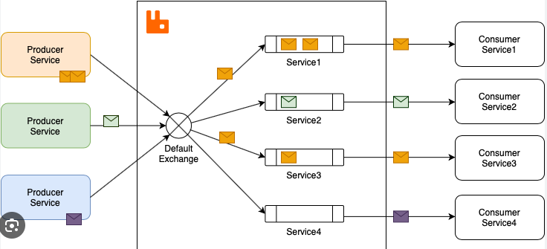

Even if a service is fail, when that service restart at that time it completes the given work using kafka

Lets Implement the Event Driven :
Step 1 :
Download Apache Kafka – I did Scala 2.12 - kafka_2.12-3.9.2.tgz (asc, sha512)
After installation extract it and set to environment variable (in path) and also add below.
Then go to kafka/config/kraft
Open reconfig-server.properties and server properties and in basic log correct the dir path
Step 2:
Run the Apache Kafka at localhost, Run the command in the cmd one by one
1] .\bin\windows\kafka-storage.bat random-uuid
returns - g7fWvPzyRyqVdbFAdmueWQ - add this below for format
2] .\bin\windows\kafka-storage.bat format -t g7fWvPzyRyqVdbFAdmueWQ -c .\config\kraft\server.properties
3] .\bin\windows\kafka-server-start.bat .\config\kraft\server.properties

These were the steps required for apache download
Now lets implement using Springboot
Step 1 :
Add the following dependency
<dependency>
<groupId>org.springframework.cloud</groupId>
<artifactId>spring-cloud-stream</artifactId>
</dependency>
<dependency>
<groupId>org.springframework.cloud</groupId>
<artifactId>spring-cloud-starter-stream-kafka</artifactId>
</dependency>

Step 2:
Do the configuration in application.properties , Here out mean out binder that is it will publish the event and in means it will consume it , The destination name used here has to be used in the other service also which will consume it.
spring.cloud.stream.bindings.orderPlacedNotification-out-0.destination=order.created
spring.cloud.stream.bindings.orderPlacedNotification-out-0.content-type=application/json
spring.cloud.stream.bindings.orderPlacedNotification-out-0.group=${spring.application.name}
spring.cloud.stream.bindings.orderPlacedNotification-in-0.destination=order.ack
spring.cloud.stream.bindings.orderPlacedNotification-in-0.content-type=application/json
spring.cloud.stream.bindings.orderPlacedNotification-in-0.group=${spring.application.name}

Step 3 :
In the notification service or consumer side add the dependency and give the configuration only difference is instead of out , it will use in for input binder(consuming the data).

spring.cloud.funtion.definition=orderPlacedNotification
spring.cloud.stream.bindings.orderPlacedNotification-in-0.destination=order.created
spring.cloud.stream.bindings.orderPlacedNotification-in-0.content-type=application/json
spring.cloud.stream.bindings.orderPlacedNotification-in-0.group=${spring.application.name}
spring.cloud.stream.bindings.orderPlacedNotification-out-0.destination=order.ack
spring.cloud.stream.bindings.orderPlacedNotification-out-0.content-type=application/json
spring.cloud.stream.bindings.orderPlacedNotification-out-0.group=${spring.application.name}

Step 4 : Publish the event
Here we pass the data orderPlacedNotification-out-0 as name and other is the message.
@Autowired
StreamBridge streamBridge;
@GetMapping("/checking")
public String checkNoti(){
streamBridge.send("orderPlacedNotification-out-0", "This is send from order");
return "Working";
}

Step 5 :
Consume the event in the notification service
@Configuration
public class OrderNotification {
@Bean
public Function<String, String> orderPlacedNotification(){
return(msg) -> {
System.out.println("Order notification sent");
return "Order Notification response "+msg;
};
}
}
Step 6 :
The notification service as we can see is returning the value, we will consume this data in the publisher event
@Configuration
public class OrderNotification {
@Bean
public Consumer<String> orderPlacedNotification(){
return(msg)->{
System.out.println("Inside acknowledgement " + msg);
};
}
}

